**Assignment -2**

Data Analytics

|  |  |
| --- | --- |
| Assignment Date | 28 September 2022 |
| Student Name | Ms. N.Ashifa |
| Student Roll Number | 19ITA05 |
| Maximum Marks | 2 Marks |

**Dashboard:**

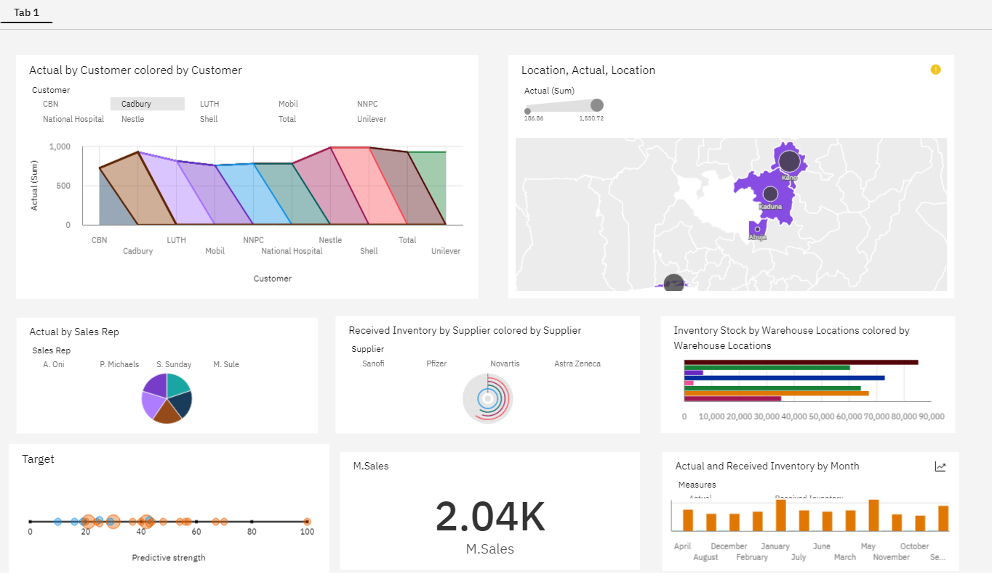

**Link:**

<https://us1.ca.analytics.ibm.com/bi/?perspective=dashboard&pathRef=.my_folders%2FAssignment-2%2FPharma%2BSales%2BCustom%2BAnalytics%2BDashboard&action=view&mode=dashboard&subView=model00000183807f785c_00000000>

**Question-1:**

Sales By Customer.

|  |
| --- |
| **Solution:** |

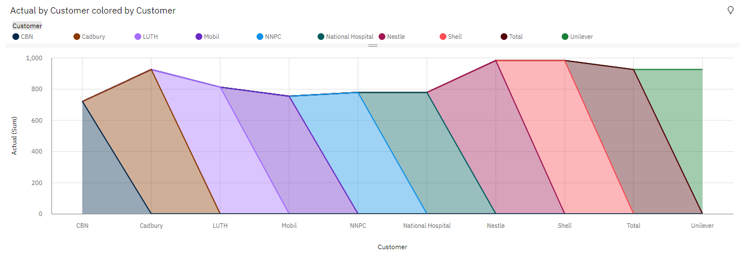

**Question-2:**

Sales By Location.

|  |
| --- |
| **Solution:** |

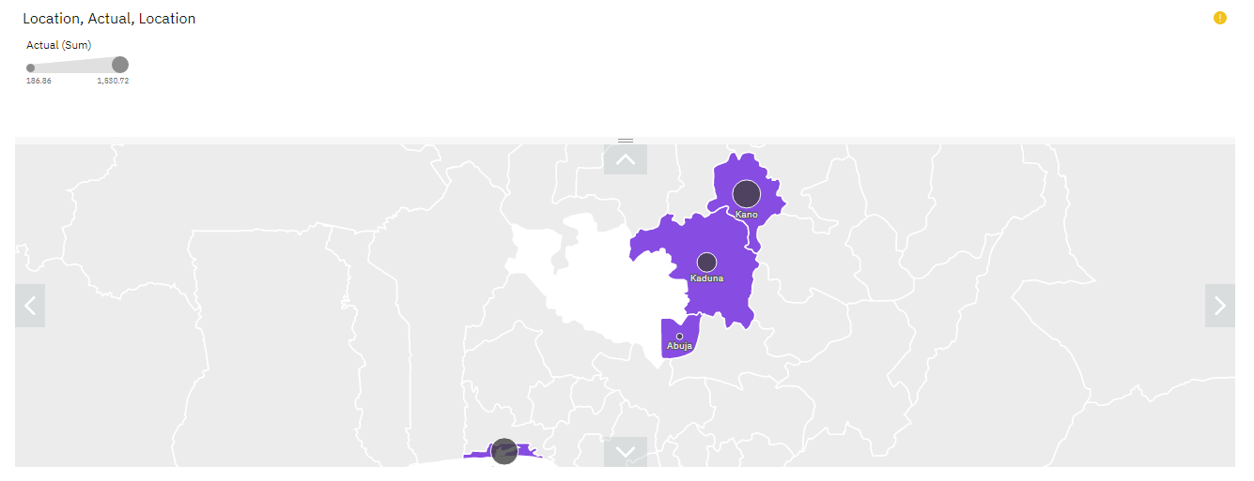

**Question-3:**

Sales By Sales Representative.

|  |
| --- |
| **Solution:** |

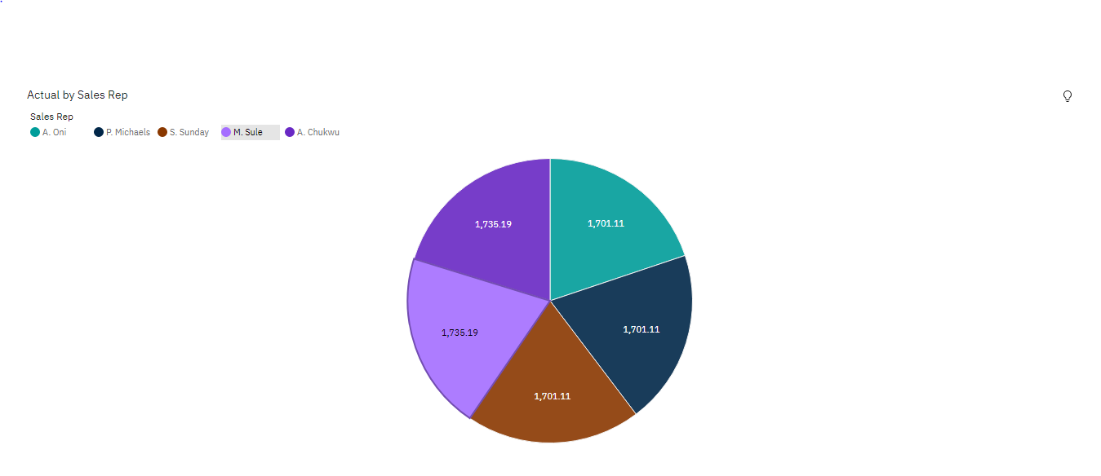

**Question-4:**

Received Inventory From Supplier.

|  |
| --- |
| **Solution:** |

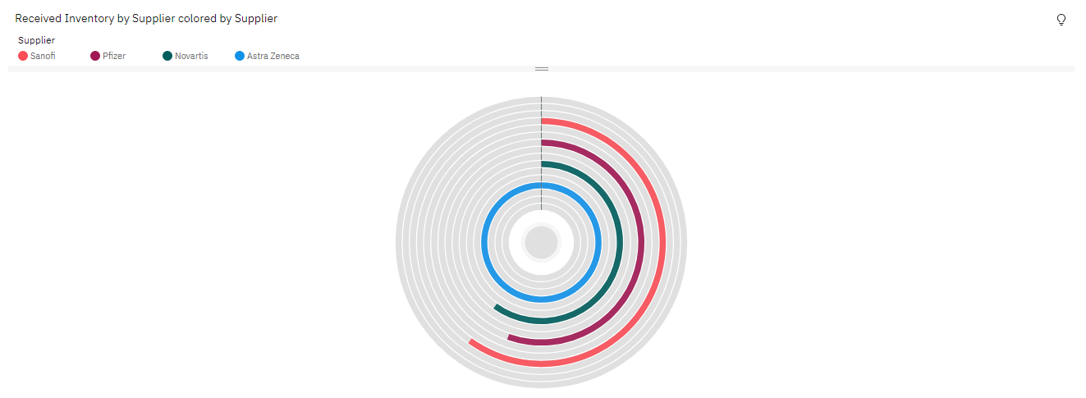

**Question-5:**

Inventory Stock for Warehouse Locations.

|  |
| --- |
| **Solution:** |

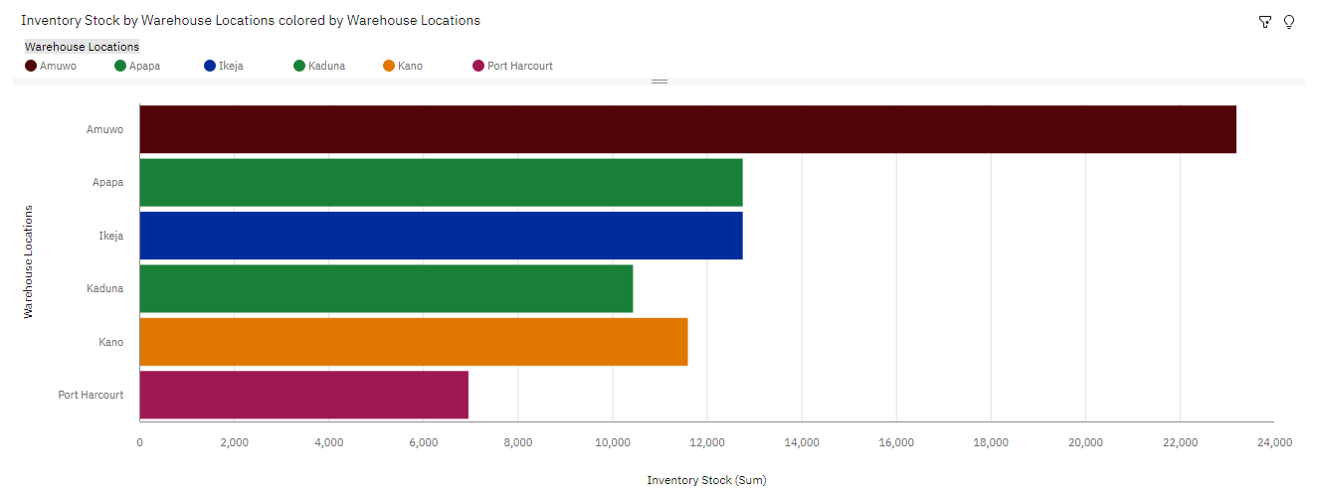

**Question-6:**

Sales Trend.

|  |
| --- |
| **Solution:** |
| **6.PNG** |

**Question-7:**

Monthly Sales.

|  |
| --- |
| **Solution:**  **7.PNG** |
| **Question-8:**  Actual and Received Inventory by Month.  **Solution:**  8.PNG   |  | | --- | |  | |